**SASTA MARIO / PIRATE ISLAND**

# ***Game Design Document***

*Game Concept*

**The game is a simple side-scroller 2D Platformer where the player needs to collect coins and eliminate continuously spawning enemies. The Player controls the main character and destroys enemies by stomping on them. The game is based on an island in pirate-theme environment with enemies and treasures.**

*Core Game Loop*

**The game is basically an adventure / exploration game with enemies and treasures.**

**Explore -> Find Enemies -> Collect Treasure -> Explore**

*Key Features / Game Mechanics*

JUMPING

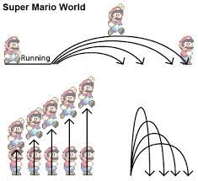**The player can jump from one platform to another by pressing the designated button. The jump is also proportional to the intensity of button press. The jump is snappy as the character falls faster than it rises.**

SQUASHING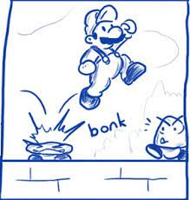

**The player can jump on top of the enemies and the enemies get squashed and die. These enemies are spawned continuously from both sides and the player either dodges them or kills them by squashing. Touching other area of the enemy kills the player.**

COIN COLLECTION

**The player can collect the coins by touching the coins with the character’s body.**

*Interface*

**The input in the game is taken from the keyboard currently. No mouse input is needed at the moment. Controller input is not necessary at the moment but may be added.**

*Art & Audio*

**The game has a pixel art style. Since it is based on an island, the art is pirate-theme based. Ships, Pirates, Treasure, Skeletons, etc. are basic example arts required in the game.**

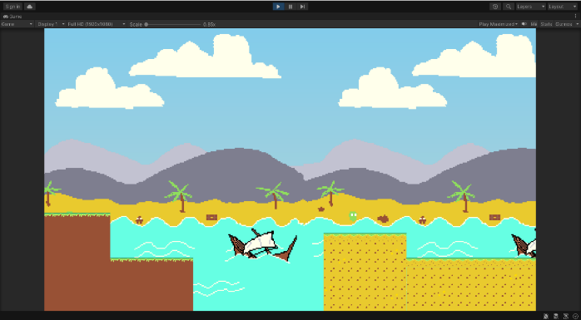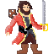 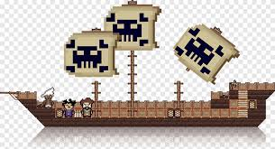 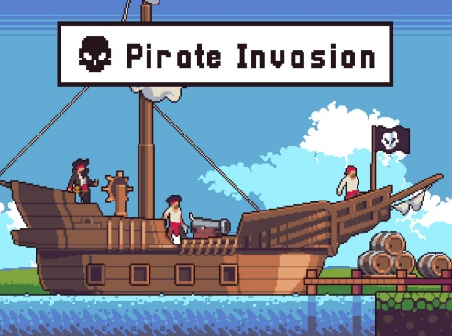

**The background music of the game changes as per the scene, but the general theme of the music is adventure and spooky. The sound effects are snappy.**